Student Worker/Graduate Assistant
Contract Submitter Instructions

A Custom Bolt-on PeopleSoft Application
Table of Contents

Student Worker Contract Entry Search Page “Find An Existing Value” Tab 3
Student Worker Contract Entry Search Page “Add A New Value” Tab 6
Student Worker Contract Submission Page 8
Graduate Student Worker Contract Submission Page 10
HR Instructions 13

Student Worker Submission Process Search and Entry

Student Worker Submission Entry Search Page “Find an Existing Value” Tab

- Navigate to SU Custom > Employment Contract Processing > Student Worker Contract > Student Worker Contract.

  - Use this search page to search for students that already have a GullNet record (contract) started, cancelled or completed.
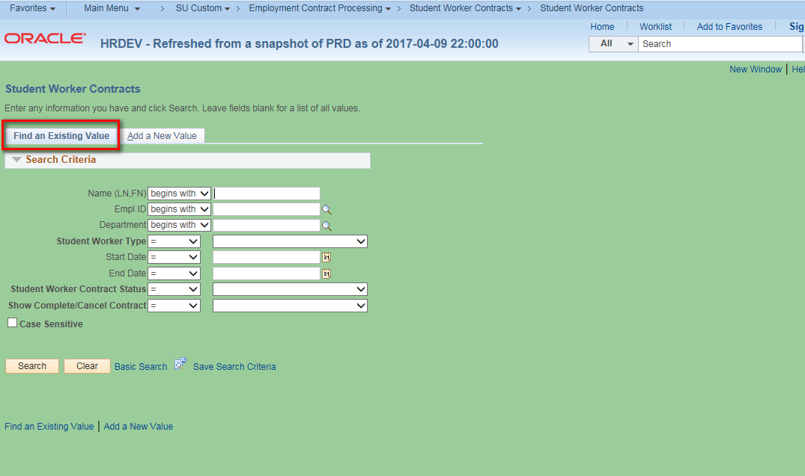

  - You can search by Name, Empl ID, Department, Student Worker Type, Dates of the Contract and/or any combination thereof. Also, you can use this to search the list by Student Worker Contract Status. The submission statuses (in normal processing order) are as follows: Not Submitted; Budget Admin Signoff Needed; Student Signoff Needed; HR Signoff Needed; HR Data Input Needed; Commitment Acct Needed; Completed; or Cancelled. Below is what you would choose to search for all students who need the Budget Administator’s signoff.
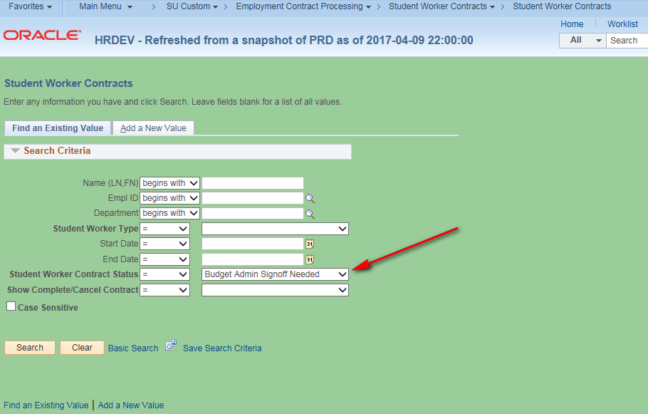

  - Also, you can search for all Completed or Cancelled Contracts by selecting as in the example below. Alternatively, choose “Contracts Waiting Action” for all contracts in process.
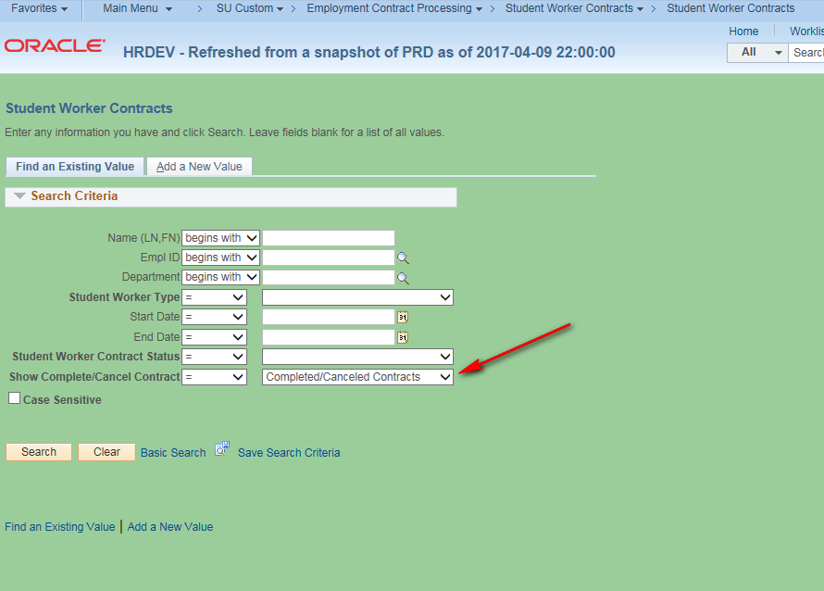

Student Worker Submission Search Page “Add A New Value” Tab
Note: This is where you select students who are employed or have never been employed and enter information in order to process their student worker contracts.

Click on the “Add a New Value” tab to select an student so you can proceed to enter a new contract.
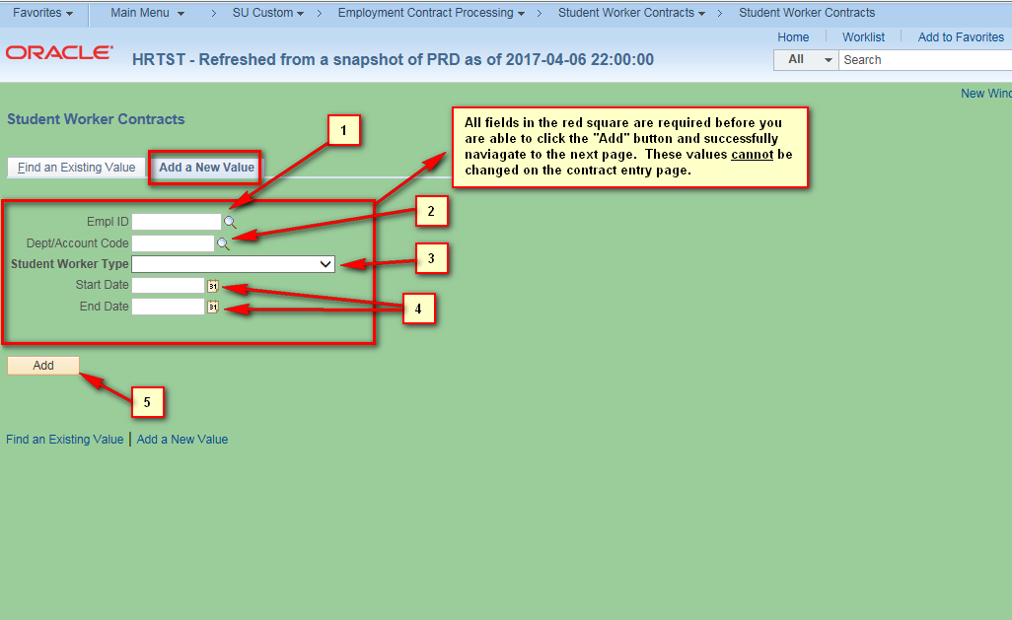

- The page shown above contains numbered field and controls (numbered for reference purposes for this document only as they do not appear on the page). They are:
  - Empl ID: If you know the emplid of the student you can enter it here or click on the magnifying glass to see a list of students. Clicking on the magnifying glass will allow you to search for the student by name. NOTE: Be very cautious and make sure you have the correct student emplid. This list includes all students past and present so it will be a very lengthy list.
  - Dept/Account Code: Enter the department code you wish to use to fund the position. If you do not see the code you wish to use, please contact HR so they can set it up.
  - Student Worker Type: Can be either “Regular Student Worker” or “Graduate Assistant”. The Student Worker Contract Submission page is built differently depending on the Student Worker Type you choose.
  - Start Date and End Date: These are the dates of the contract.
  - Clicking the yellow “Add” button in the screenshot above will take you to the Student Worker Contract Submission page. Note: If Graduate Assistant skip to page 10.

Student Worker Contract Submission Page – Regular Student Worker

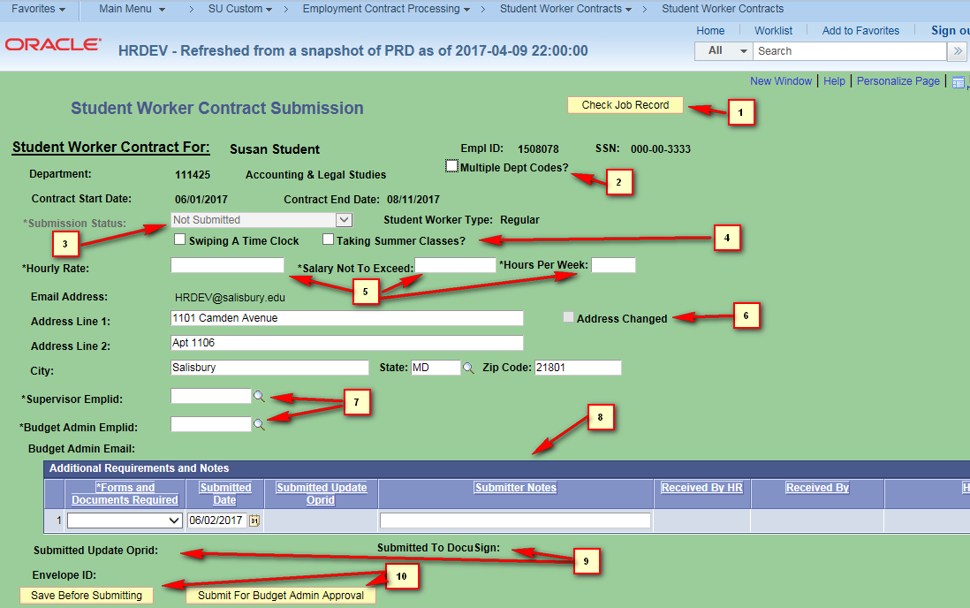

- The page shown above contains numbered field and controls (numbered for reference purposes for this document only as they do not appear on the page). They are:

  - The “Check Job Record” button allows you to see the job records of the student employee if available. They are based on the Empl Record of the student and include active as well as non-active jobs. The “Future Jobs” button shows contracts entered in HR that have not started yet. These are for informational purposes only.
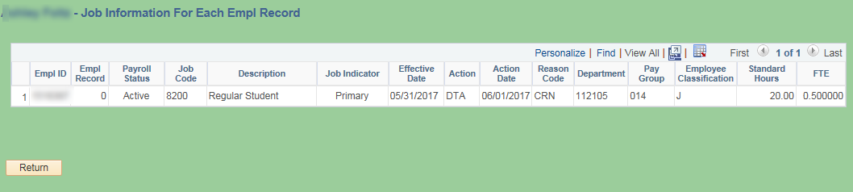
  - Multiple Dept Codes?: Only check this when you will be allocating the contract salary among more than one department code. It opens a small data entry window where you must enter at least two department codes. The pecentages must add up to 100. Contact HR if you do not see your department codes when you select the department magnifying glass.
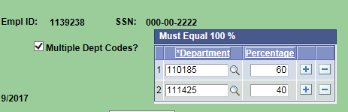

  - Submission Status: This is a read-only field and is set to “Not Submitted” until the contract has been submitted.
  - Two checkboxes which you would check if the student is swiping a time clock and/or taking summer classes.
  - Three required fields for Hourly Rate (must be at least minimum wage), Maximum Salary and Hours Worked Per Week.
  - Address Changed: This checkbox is not editable and only is checked if you change any address information. When the page is loaded the home address of the student is loaded. If you modify any of the fields (Address Line 1 or 2, City, State, or Postal Code) this box will be checked when the address is changed. This will alert the HR Office to send the sudent the proper paperwork needed to formally change the home address.
  - Supervisor Emplid and Budget Admin Emplid: The supervisor must be chosen from a list of current employees. The Budget Administrator will normally only have one value selectable from the search magnifying glass. This value is tied to the Department in which the student will be working. When selected, the email addresses below the emplid will automatically be populated. If there are no values when you click the magnifying glass contact HR.
  - Additional Requirements and Notes: These are additional documents required or notes that you can enter that the student will have to provide based on their job information (contact HR for further clarification). Please leave as “None” if no additional documents are required or if you have no notes to make.
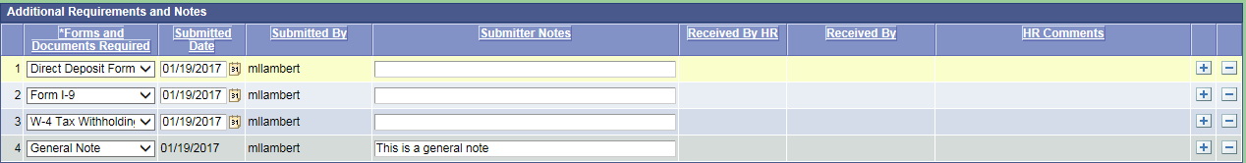

  - Submitted Oprid and Submitted Date: These read only fields are populated when you submit the contract.
  - The “Save Before Submitting” button can be pressed to save all your data without submitting the contract process through DocuSign. The “Submit For Budget Admin Approval” button actually starts the DocuSign workflow process.

Student Worker Contract Submission Page – Graduate Assistant Worker

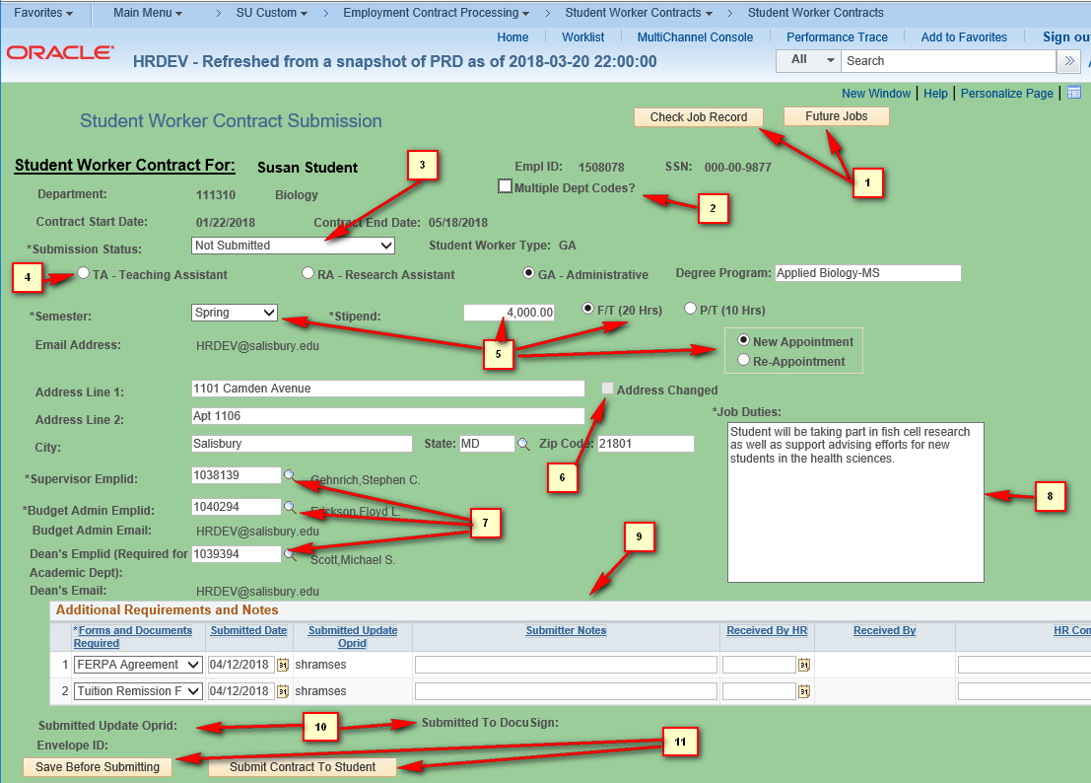

- The page shown above contains numbered field and controls (numbered for reference purposes for this document only as they do not appear on the page). They are:

  - The “Check Job Record” and “Future Jobs” buttons allow you to see the job records of the student employee if available. They are based on the Empl Record of the student and include active as well as non-active jobs. The “Future Jobs” button shows contracts entered in HR that have not started yet. These are for informational purposes only.
  - Multiple Dept Codes?: Only check this when you will be allocating the contract salary among more than one department code. It opens a small data entry window where you must enter at least two department codes. The pecentages must add up to 100. Contact HR if you do not see your department codes when you select the department magnifying glass.

  - Submission Status: This is a read-only field and is set to “Not Submitted” until the contract has been submitted.
  - This radio button defines the type of graduate student worker. You must select one. Also, enter the degree program in which the graduate student is enrolled..
  - You must select the semester for which the student is employed as well as enter the amount of their stipend. Also, please pick the amount of hours they are working per week from the F/T and P/T radio buttons. Also, please select whether the graduate student is a new appointment or re-appointment.
  - Address Changed: This checkbox is not editable and only is checked if you change any address information. When the page is loaded the home address of the student is loaded. If you modify any of the fields (Address Line 1 or 2, City, State, or Postal Code) this box will be checked when the address is changed. This will alert the HR Office to send the sudent the proper paperwork needed to formally change the home address.
  - Supervisor Emplid and Budget Admin Emplid: The supervisor must be chosen from a list of current employees. The Budget Administrator will normally only have one value selectable from the search magnifying glass. This value is tied to the Department in which the student will be working. When selected, the email addresses below the emplid will automatically be populated. If there are no values when you click the magnifying glass contact HR. The Dean’s emplid is required for all academic departments since approvals will be routed to them before final signoff by the Dean of Graduate Studies.
  - Please enter a brief description of the graduate worker’s job duties.
  - Additional Requirements and Notes: These are additional documents required or notes that you can enter that the student will have to provide based on their job information (contact HR for further clarification). Please leave as “None” if no additional documents are required or if you have no notes to make. Additionally, graduate workers may need to sign a FERPA agreement as well as submit a tuition remission form.

  - Submitted Oprid and Submitted Date: These read only fields are populated when you submit the contract.
  - The “Save Before Submitting” button can be pressed to save all your data without submitting the contract process through DocuSign. The “Submit For Budget Admin Approval” button actually starts the DocuSign workflow process.

HR Instructions

When the contract “Submission Status:” is “HR Data Input Needed” it is ready for HR submission. The section below is only visible to HR staff.

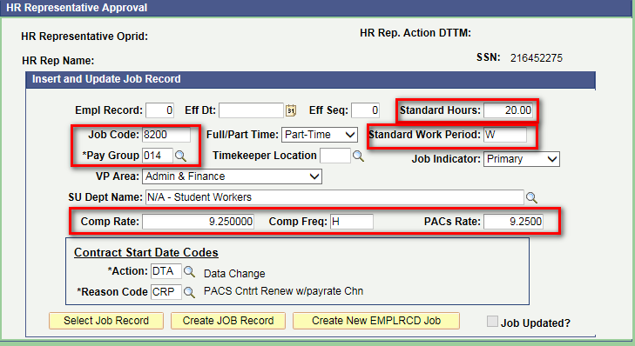

- The page shown above contains fields which will be used to populate the Job record of the student when the HR submitter clicks on the “Create JOB Record” or “Create New EMPLRCD Job” button.
- Fields that are in the red squares will be populated from data entered by the contract administrator who started the contract process. HR may still edit these though if they wish. All other fields are defaulted or as in the case of the “Action” and “Reason” code fields are determined by the program or “Select Job Record” button. These are all editable by the HR rep.
- When the HR submitter clicks on the “Select Job Record” they will see a list of all the highest job rows for each EMPL_RCD for that student. Clicking the select button at the end of the row will populate the data for all the fields that are not in red squares if the data is available. These fields are also editable if you wish to use your own values.
- The “Contract Start Date Codes” box and fields are critical since they determine how the job record is created in HR. Please make sure these are correct before you submit via the “Create JOB Record” button or the “Create New EMPLRCD Job” button.
- Once the the HR submitter clicks on the “Create JOB Record” button ” or “Create New EMPLRCD Job” button the “Job Updated?” check box will become checked and the submission status will be updated to “Commitment Acct Input Needed”, but if there is an error please contact IT.
- NOTE: Please use the “Create New EMPLRCD Job” button for a student who has never had a job record in HR or for one whom you wish to create a new EMPL record.

