Company Name

{INSERT LOGO}

Business Plan

Founder Name(s)

Month 202X

# The Big Idea

INSTRUCTIONS: Describe your idea and start to flesh out your business model. What makes your idea work? How is it different from competitors?

## 7-Word Summary

INSTRUCTIONS: Provide a concise description of your company, product, or service in 7-words or less that emphasizes your unique differentiators, specialization, or focus.

## The Problem

INSTRUCTIONS: Briefly describe what problem you are solving for your customers. Why is this problem painful? How painful is it to users? What are the impacts and root causes? Use quantitative data or other evidence to support claims.

## The Solution

INSTRUCTIONS: Describe the products and/or services your company will offer to address the problem identified above. How is your proposed solution unique and innovative? Is it feasible given existing technology and your resources and capabilities? What makes your company, product, or service competitive? Is your competitive advantage sustainable?

|  |
| --- |
| **REFERENCE:**  In the 1970s, Dr. Michael Porter posited firms compete in one of three ways. Companies either win by offering the lowest price (COST), by building unique features or capabilities (DIFFERENTIATION), or targeting a niche segment of customers (FOCUS). |

## Business Model

INSTRUCTIONS: Complete the business model diagram to think through key elements of your company at a high level.

|  |
| --- |
| **REFERENCE:**  The 9-Block Business Model Canvas was created by Alexander Osterwalder & Yves Pigneur in 2010 as an Open Source reference for formulating startup business models. The tool helps you quickly map the key points of your business that form the foundation of your marketing, operations, and financial plans. |

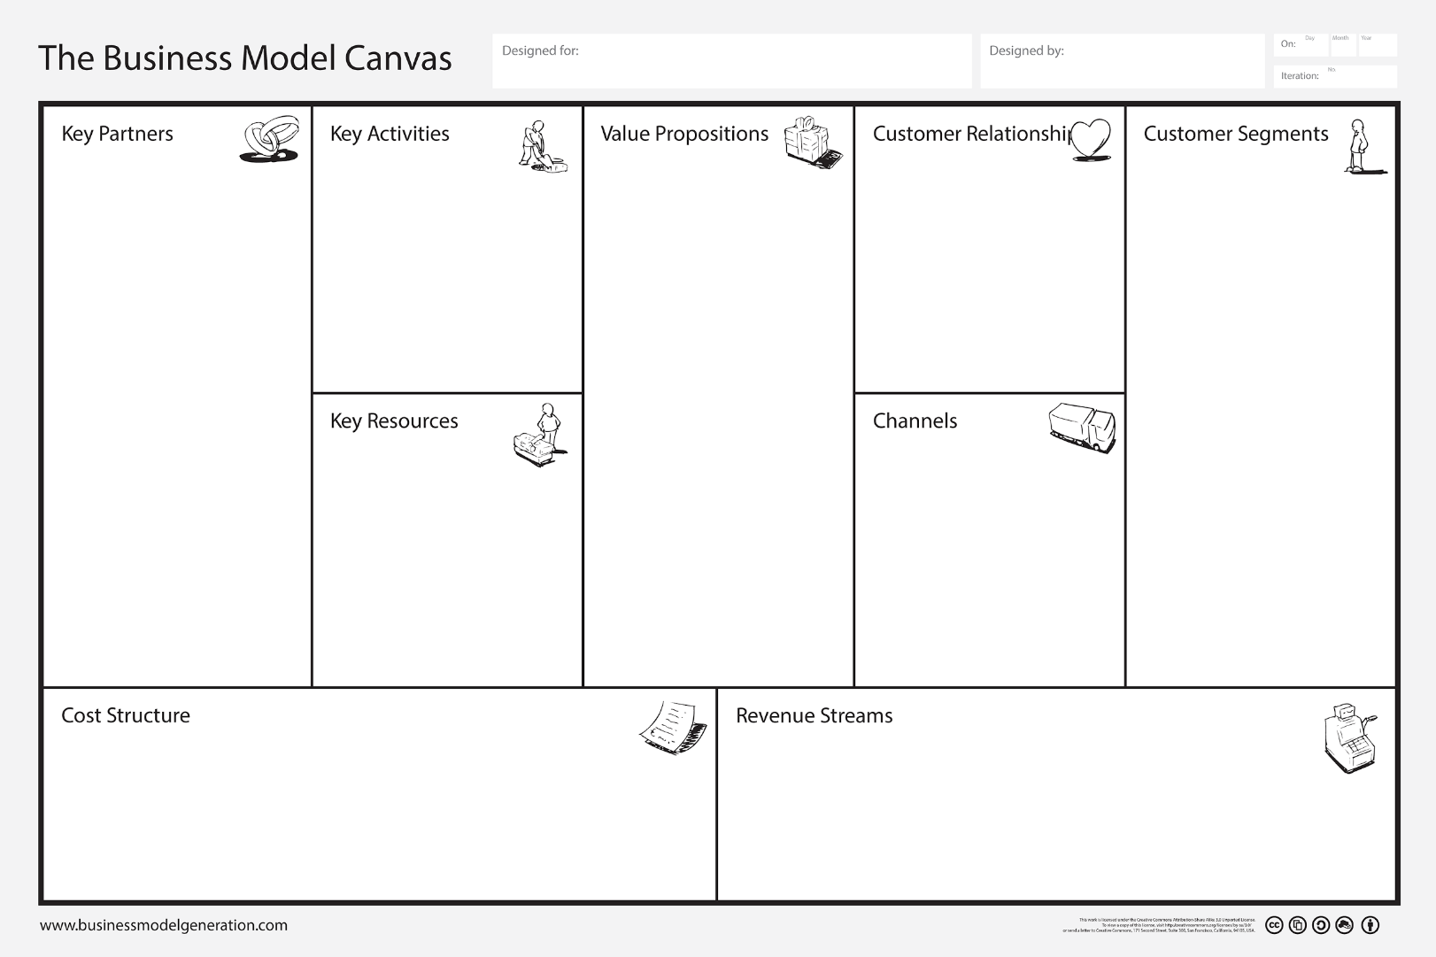

Niche markets, key segments, diversified or mass markets

*Focus on key early stage customers*

Physical Assets, Intellectual Property, Human Talent, Capital

*Those that drive value*

Transactional, Personal, Community, Automated, Self-service, Co-Creation, etc.

Sales force, website, store, wholesaler, etc. across customer journey

*Awareness, evaluation, purchase, delivery, after sales*

Production, Network Building, Service Delivery, Customer Support, etc.

*Those that drive value*

Product Sale, Usage Fee, Subscription,  
Rental, Licensing, Ad Revenue,   
Broker Fees, Freemium, etc.

*Fixed or Dynamic (Auctions, Negotiation, etc.) Pricing*

Costs associated with key partners, key activities,   
and key resources (above)

*Consider fixed and variable costs*

Proposition 1

Proposition 2

Proposition 3

…

*One for each customer segment identified – should align with your competitive strategy*

Partner 1

Partner 2

Partner 3

…

*Those external parties essential for operational success or scaling. Consider distribution, manufacturing, and supply chain partners.*

Segment 1

Segment 2

Segment 3

…

Relationship 1

Relationship 2

Relationship 3

…

|  |
| --- |
| **RECOMMENDED VALUE PROPOSITION FORMULA:**  We help ___**A**___ to ___**B**___ by ___**C**___.  Where:  A = customer segment (as focused and specific as possible)  B = primary benefit (unique)  C = unique method, technique, or approach |

# Opportunity Evaluation & Customer Discovery

INSTRUCTIONS: Make sure your idea is a valid one. Gather data through market research that may include both qualitative (interviews, focus groups) and quantitative (surveys, secondary data sources, experiments). The most important step, regardless of strategy, is to talk with potential customers in a process called “Customer Discovery.” In general, entrepreneurs should strive to speak with over 50 targets. Start with friends and family. Obtain referrals and expand your list.

## Critical Customer Segment(s)

INSTRUCTIONS: Who are your customers? Describe who will use your product or services. Quantify the size and rate of growth or decline of your market using online and secondary research such as data obtained by the US Census Bureau (Census) or the Bureau of Labor Statistics (BLS). Use Customer Journey Maps and Personas to help explore pain points, needs, and priorities. Seek to dominate a small niche instead of being a small player in a large market. Identify your early adopters and how you can connect with them.

## Competitor Analysis

INSTRUCTIONS: Who is also providing products or services to meet customer needs currently? Are their significant indirect competitors in play? Quantify the scale of your competition by collecting data on your sector from industrial directories, yellow page listings, or government databases such as the Census County Business Patterns or BLS. Evaluate your closest competitors – i.e. the ones you will mostly likely need to steal customers from or compete with in the marketplace. Conduct a deep dive on their brand positioning, marketing tactics, pricing strategies, value propositions, product and service quality, online customer feedback and reviews, digital media, etc. Use market GIS analysis or market positioning grids to help organize your analysis.

## Industry Landscape

INSTRUCTIONS: What is the size of the industry? Overall, is it growing or declining? How fast? What are the most significant changes or trends occurring in your industry? This may include such things as new technology innovations, customer purchasing behaviors, and government regulations. Consider using Dr. Michael Porter’s 5-Forces Analysis, the PEST Framework, or a SWOT Analysis when analyzing your industry. These models provide structure to industry evaluations.

|  |
| --- |
| **REFERENCE:**  Select only rapidly-growing industries. Research indicates that profitability is directly and significantly tied to industry growth rates. A rapidly growing industry provides more opportunities to acquire new customers instead of the more difficult task of stealing customers from existing companies. In a declining industry, existing companies are fighting ever harder over an ever-eroding customer base. Choose where to complete wisely. |

# Go-to-Market Strategy

INSTRUCTIONS: A Go-to-Market Strategy will test one of two critical hypotheses about your startup business – can you effectively and sustainability drive customers to your product or service through marketing and sales operations over the first 3-6 months of your business?

## Innovators & Early Adopters

INSTRUCTIONS: Specifically identify who within your targeted customer segment(s) are most likely to be the first to respond to your offering. Innovators and Early Adopters are more open to testing early prototypes and first editions that may still lack polish. Think about who has the greatest demand or is experiencing the most pain from the identified problem as well as who is most readily accessible. Be as NARROW as possible to identify your earliest customers. Quantify the size of this narrow market segment and use customer interviews or other research to profile who these customers are, what their priorities are, and where they hang out.

**REFERENCE:**Technology diffuses through a society in a standard way. Everett Rogers developed a theory on the diffusion of innovations in the 1960s. As depicted below innovators and early adopters only comprise 16% of your total market and innovators – those most likely to test out your idea – represent only 2.5% of your market.

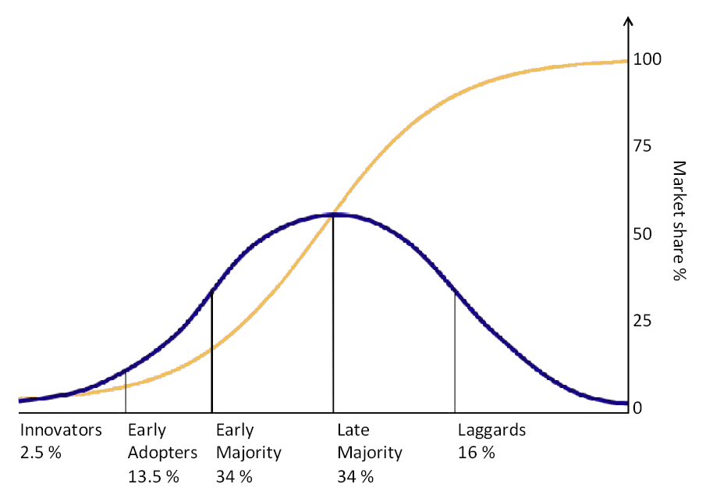

By Tungsten - self-made based on Rogers, E. (1962) Diffusion of innovations. Free Press, London, NY, USA., Public Domain, <https://commons.wikimedia.org/w/index.php?curid=8043923>

## Brand & Messaging

INSTRUCTIONS: Describe you company’s branding and messaging to this niche market segment. How will you communicate your value offering and differentiation? Include key elements of your brand to include colors, fonts, logos, icons, language, stories, etc. that are critical to the launch of your company. This can also include operational issues that reinforce branding such as customer greetings or opening hours.

## Pricing Structure

INSTRUCTIONS: Pricing plays a key role in value signaling and brand positioning. Identify your pricing or pricing strategy. Include how this pricing reinforces your business strategy and brand identity.

## Marketing Channels

INSTRUCTIONS: You will need a way to contact your customers and present your marketing messages. This may include a website, social media accounts, physical store, salesforce, third-party digital marketplaces, and more. Be sure your channel selection and design align with the nature of customer relationship desired. Describe the development and investments needed to create or maintain these channels.

## Advertising

INSTRUCTIONS: Opening a store or launching a website are typically insufficient by themselves for recruiting new customers in the targeted market segments. Startup companies should identify a series of outreach efforts that drive customers to the various channels the firm has put in place. This could include traditional or digital advising, but many startups also need specialized and aggressive tactics to gain attention, leverage viral network effects, and connect with their early adopter market.

## Sales

INSTRUCTIONS: Businesses also need to consider their sales process. This may include a description of customer-facing employee service training, in-person sales presentations, or other conversations and connections. This could also include a scheme for discounts and referrals. Define your sales process and the supporting elements that will lead to sales success.

## Metrics & Goals

INSTRUCTIONS: Determine how you will track the success of your marketing, advertising, and sales activities. Most obviously, this should include customer acquisition and sales revenue. However, other variables may be equally or more important to a startup such as contacts made, presentations delivered, followers, clicks, shares, or other metrics. Identify the 3-5 metrics most important to your company’s marketing success tied to key operational or strategic objectives. Then create goals or targets for your first iteration tied to your financial model (i.e. how many of X is needed to show a path to profitability is possible).

# Operations Plan

INSTRUCTIONS: The Operations Plan test the second major startup hypothesis – can your firm deliver something of real value to the customer? This includes customer responses to your product or service, but also the validation of the costs, processes, and requirements for producing that good or service.

## Minimum Viable Product (MVP)

INSTRUCTIONS: Identify the firm’s first product or service iteration and explain why this offering meets the MVP criteria: a fast, low-cost test of the venture’s riskiest assumptions. If an MVP is not yet viable, describe how you will undertake the necessary prototyping and market validation activities to test your concept.

## Production Processes

INSTRUCTIONS: Describe the requirements for delivering this product or service. This may include manufacturing or assembly operations (for a product) or expert time spent on tasks (for a service). High level process diagrams may be used to define these activities. Remember, the focus is on delivering only your MVP level of quality and complexity.

## Purchasing & Distribution Channels (Supply Chain)

INSTRUCTIONS: Companies typically require inputs and produce outputs – either end user applications or as part of a value chain. Identify any critical channels for purchasing (acquiring inputs) or distributions (delivering outputs), including shipping and delivery to customers if applicable.

### Product Packaging

INSTRUCTIONS: If delivering a product, describe the packaging and/or labeling.

## Customer After-sales Support, Training & Service (Returns)

INSTRUCTIONS: Describe what happens after the sale and delivery of your product or service. How will your company deal with customer problems? What support will to provide to ensure customers are able to use or apply your product or service correctly? How will you encourage retention and customer loyalty?

## Key Partners

INSTRUCTIONS: Identify any organizations that are critical to the success of your company’s operations. This may include suppliers, distributors, advisors, service providers, or other partners. Describe their role and if alternatives/replacements/backups are available.

## Key Resources

INSTRUCTIONS: What are your key resources other than personnel? This may include proprietary formulas, unique product designs, patent pending innovations, or other intellectual property; key pieces of equipment or unique access to facilities; proprietary processes or standard operating procedures (SOPs) for service delivery; or other specialized assets your firm will use in developing or deploying the initial product offering.

## Startup Personnel & Staff

INSTRUCTIONS: Who are your company’s key staff members (include: name, position, area of responsibility, and relevant background)? Provide a general description of staffing requirements outside of these key positions. An organization chart can be used if there are many personnel.

|  |
| --- |
| **STARTUP NEEDS:**  In general, startup teams require three essential capabilities which can be fulfilled through the founders directly or by hiring staff or contractors:   1. Somebody, typically the founder, who is a subject matter expert in the technology, product, service, and operational issues (focused on the Operations Plan). 2. Somebody with creative ability who is strong in marketing and sales (focused on the Marketing Plan). 3. Somebody good with numbers who can handle the firm’s accounting and financial management activities (focused on the Financial Plan). |

## Metrics & Goals

INSTRUCTIONS: Non-revenue/sales operational metrics can be difficult to identify. However, it is important to measure the efficiency and productivity of your business processes as well as customer feedback and responses. Identify metrics and establish targets for operational variables such as costs and expenses, hours spent, and client retention.

# Business Organization

INSTRUCTIONS: In order to get started in business, you must be legally registered and, in some cases, licensed by the state where the business will be established. This section reviews the key steps to prepare for getting your business off the ground. The Small Business Development Center (SBDC) is often a good go-to resource for setting up your business.

## Business Insurance

INSTRUCTIONS: Most businesses should have some form of general liability business insurance. Companies in some industries, like food services, must have insurance to operate. Other forms of insurance are required to hire employees. Check with an insurance agent or the SBDC on insurance requirements for your particular company.

## Licenses, Certifications, Inspections, & Registrations

INSTRUCTIONS: Some businesses must obtain specialized licenses with the local or state government, comply with local zoning permits, or need industry certifications in order to demonstrate competency in their field. Check with your state and local government commerce or business agencies to identify and comply with these requirements. List these additional requirements here.

## Legal Business Structure

INSTRUCTIONS: Businesses can organize as a Sole Proprietorship, Partnership, Limited Liability Corporation (LLC), Limited Liability Partnership, or Corporation. Most startup companies working with our programs should consider registering as an LLC, but there are pros and cons with each type of business structure. Once registered, you will obtain an identification number from your state authority.

## IRS EIN Number

INSTRUCTIONS: Companies need to register with the IRS to receive an EIN number (like a SSN for a business instead of an individual). This is required in order to hire employees.

## Tax Accounts

INSTRUCTIONS: Businesses must pay certain taxes such as sales, use, and hotel occupancy taxes. Other taxes are required when a business takes on employees. Companies must create accounts with the appropriate state agencies to record these tax liabilities and payments.

## Bank Accounts, Recordkeeping & Accounting Systems

INSTRUCTIONS: Companies must have an account with a banking institution in order to receive and disperse payments. Often, basic small business checking accounts are free. Businesses must also maintain financial records in hard copy, a spreadsheet, and/or accounting software. Describe those systems here and identify your bookkeeping or accounting service provider.

# Financial Projections

INSTRUCTIONS: Identify your startup capital requirements and operational expenses for the first iteration. Avoid making long-term forecasts until actual revenue and operational data is available.

## Startup Costs

INSTRUCTIONS: How much money do you need to launch your firm? How much do you specifically need for completing the next iteration of your business? Think through all the expenses needed to get your operations off the ground initially. It may include such items as equipment, computers, and business registration fees. Record those items here.

## Fixed Expenses

INSTRUCTIONS: Identify the ongoing fixed expenses for your business. These typically include such items as rent, marketing services, accounting services, utilities, etc.

## Variable Expenses

INSTRUCTIONS: Identify the variable expenses for your business. These should be listed on a per unit basis wherever possible and include such items as materials, supplies, labor, transaction fees, and shipping costs. How much does it cost to produce one unit?

## Revenue Streams

INSTRUCTIONS: Describe how your firm will make money and (eventually) generate a profit. Profits may not be realized during the initial iteration of your business. Determine what level of customer activity (e.g. number of users, units of product sold, subscribers, etc.) is needed to break even. Define your basis of estimates for revenue expectations using reasonable forecasts backed by research wherever possible. Apply churn rates, click funnel metrics, or other benchmarks to tie those numbers to realistic projections of activity and sales.

## Financial Statements

INSTRUCTIONS: Include your startup’s three financial statements and an analysis of key metrics and ratios, as applicable. The standard financial statements are the Income Statement, Cashflow Statement, and Balance Sheet. A quick Google search will provide you with instructions on how these documents work. Our Financial Forecasting Template (Excel file) creates these statements for you. They can be copied and pasted from that file when you complete your financial modeling.