Organization Name

{INSERT LOGO}

Business Plan

Founder Name(s)

Month 202X

# Organization Description

INSTRUCTIONS: Provide a concise description of what your organization does, the need it addresses, and the services it provides.

## Mission

INSTRUCTIONS: Write a one or two sentence mission statement that defines the purpose of your organization.

## Vision

INSTRUCTIONS: Describe your vision for the nonprofit organization. What will your organization look like in 5 or 10 years if it completes its mission? What services might you provide and what impact will you be having in the community?

## Goals

INSTRUCTIONS: Identify 3-5 goals. The goals should be specific and targeted. Define the objectives you need to achieve in order to fulfill your mission and fulfill your vision?

## Business Model

INSTRUCTIONS: Complete the business model diagram to think through key elements of your organization at a high level. This tool was designed for for-profit companies, but nonprofits must also understand the essential elements of their organization’s operations.

|  |
| --- |
| **REFERENCE:**  The 9-Block Business Model Canvas was created by Alexander Osterwalder & Yves Pigneur in 2010 as an Open Source reference for formulating startup business models. The tool helps you quickly map the key points of your business that form the foundation of your marketing, operations, and financial plans. |

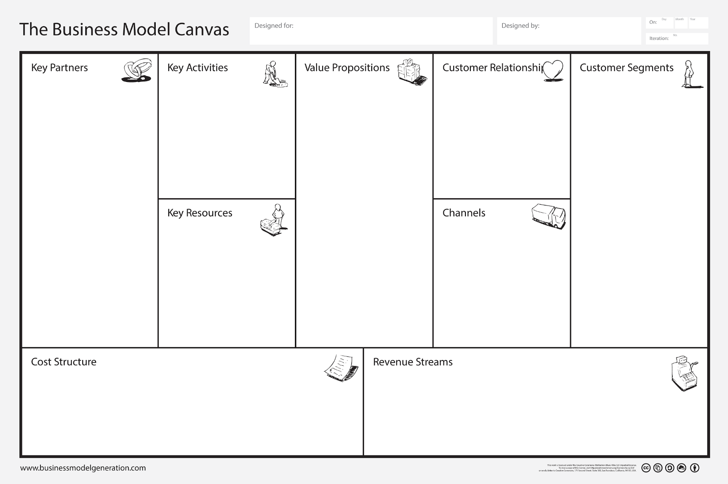

Niche markets, key segments, diversified or mass markets

*Focus on key early stage customers*

Physical Assets, Intellectual Property, Human Talent, Capital

*Those that drive value*

Transactional, Personal, Community, Automated, Self-service, Co-Creation, etc.

Sales force, website, store, wholesaler, etc. across customer journey

*Awareness, evaluation, purchase, delivery, after sales*

Production, Network Building, Service Delivery, Customer Support, etc.

*Those that drive value*

Product Sale, Usage Fee, Subscription,  
Rental, Licensing, Ad Revenue,   
Broker Fees, Freemium, etc.

*Fixed or Dynamic (Auctions, Negotiation, etc.) Pricing*

Costs associated with key partners, key activities,   
and key resources (above)

*Consider fixed and variable costs*

Proposition 1

Proposition 2

Proposition 3

…

*One for each customer segment identified – should align with your competitive strategy*

Partner 1

Partner 2

Partner 3

…

*Those external parties essential for operational success or scaling. Consider distribution, manufacturing, and supply chain partners.*

Segment 1

Segment 2

Segment 3

…

Relationship 1

Relationship 2

Relationship 3

…

|  |
| --- |
| **RECOMMENDED VALUE PROPOSITION FORMULA:**  We help ___**A**___ to ___**B**___ by ___**C**___.  Where:  A = customer segment (as focused and specific as possible)  B = primary benefit (unique)  C = unique method, technique, or approach |

# Opportunity Evaluation & Participant Discovery

INSTRUCTIONS: Make sure your idea is a valid one. Gather data through market research that may include both qualitative (interviews, focus groups) and quantitative (surveys, secondary data sources, experiments). The most important step, regardless of strategy, is to talk with potential participants in a process called “Discovery.” In general, startup nonprofit leaders should strive to speak with over 50 targets. Start with friends and family. Obtain referrals and expand your list.

## Need Statement

INSTRUCTIONS: Identify the need you want to address. Describe the extend of the problem, its impacts, and root causes. Use a mix of qualitative (story) and quantitative data to communicate the importance and scope of the issue.

## Critical Participant Segment(s)

INSTRUCTIONS: Who are your participants – i.e. the people receiving services? Describe who will utilize your organization’s products or services. Quantify the size and rate of growth or decline of your participant segment using online and secondary research such as data obtained by the US Census Bureau (Census) or the Bureau of Labor Statistics (BLS). Use Customer Journey Maps and Personas to help explore pain points, needs, and priorities. Seek to dominate a small niche instead of being a small player in a large market. Identify your early adopters and how you can connect with them.

## Existing Provider Analysis

INSTRUCTIONS: Who is also providing products or services to meet participant needs currently? How is this problem being solved or addressed right now? Quantify the scale of existing service providers by collecting data on your sector from industrial directories, yellow page listings, or government databases such as the Census County Business Patterns or BLS. Evaluate your closest nonprofit or institutional competitors – i.e. the ones you will mostly likely compete with for donor attention and fundraising. Conduct a deep dive on their brand positioning, outreach tactics, donor strategies, value propositions, product and service quality, online customer feedback and reviews, digital media, etc. Use market GIS analysis or market positioning grids to help organize your analysis.

## Industry Landscape

INSTRUCTIONS: What is the size of the industry? Overall, is it growing or declining? How fast? What are the most significant changes or trends occurring in your industry? This may include such things as new technology innovations, customer purchasing behaviors, and government regulations. Consider using Dr. Michael Porter’s 5-Forces Analysis, the PEST Framework, or a SWOT Analysis when analyzing your industry. These models provide structure to industry evaluations.

|  |
| --- |
| **REFERENCE:**  Select only rapidly-growing industries. Research indicates that profitability is directly and significantly tied to industry growth rates. A rapidly growing industry provides more opportunities to acquire new customers instead of the more difficult task of stealing customers from existing companies. In a declining industry, existing companies are fighting ever harder over an ever-eroding customer base. Choose where to complete wisely. |

# Outreach Plan / Go-to-Market Strategy

INSTRUCTIONS: A Go-to-Market Strategy will test one of two critical hypotheses about your startup nonprofit - can you effectively and sustainability engage a critical mass of participant, volunteers, and donors to operate your nonprofit business model over the first 3-6 months of your business?

## Innovators & Early Adopters

INSTRUCTIONS: Specifically identify who within your targeted participant, volunteer, and donor segment(s) are most likely to be the first to respond to your offering. Innovators and Early Adopters are more open to testing early prototypes and first editions that may still lack polish. Think about who has the greatest demand or is experiencing the most pain from the identified problem as well as who is most readily accessible. Be as NARROW as possible to identify your earliest stakeholders. Quantify the size of this narrow segment and use interviews or other research to profile who these stakeholders are, their priorities, and where they hang out.

**REFERENCE:**Technology diffuses through a society in a standard way. Everett Rogers developed a theory on the diffusion of innovations in the 1960s. As depicted below innovators and early adopters only comprise 16% of your total market and innovators – those most likely to test out your idea – represent only 2.5% of your market.

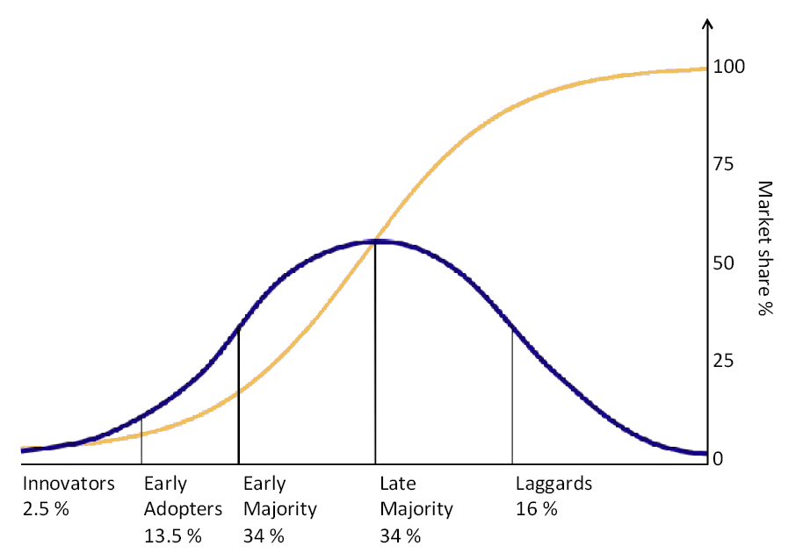

By Tungsten - self-made based on Rogers, E. (1962) Diffusion of innovations. Free Press, London, NY, USA., Public Domain, <https://commons.wikimedia.org/w/index.php?curid=8043923>

## Brand & Messaging

INSTRUCTIONS: Describe you organization’s branding and messaging to this niche segment. How will you communicate your value offering and differentiation? Include key elements of your brand to include colors, fonts, logos, icons, language, stories, etc. that are critical to the launch of your company. This can also include operational issues that reinforce branding such as customer greetings or opening hours.

## Fee Structure

INSTRUCTIONS: Pricing plays a key role in value signaling and brand positioning. Identify your pricing or pricing strategy. Include how this pricing reinforces your strategy and brand identity.

## Outreach Channels

INSTRUCTIONS: You will need a way to contact your target audience and present your outreach messages. This may include a website, social media accounts, physical store, salesforce, third-party digital marketplaces, and more. Be sure your channel selection and design align with the nature of stakeholder relationship desired. Describe the development and investments needed to create or maintain these channels.

## Advertising

INSTRUCTIONS: Opening a store or launching a website are typically insufficient by themselves for recruiting new customers in the targeted market segments. Startup companies should identify a series of outreach efforts that drive customers to the various channels the firm has put in place. This could include traditional or digital advising, but many startups also need specialized and aggressive tactics to gain attention, leverage viral network effects, and connect with their early adopter market.

## Donor Development

INSTRUCTIONS: How will your nonprofit connect with donors and raise funds? Provide any details on your giving tiers, donation payment gateways, and fundraising strategies.

## Metrics & Goals

INSTRUCTIONS: Determine how you will track the success of your outreach, advertising, and fundraising activities. Most obviously, this should include total donations received. However, other variables may be equally or more important to a startup such as contacts made, presentations delivered, number of donors, followers, clicks, shares, or other metrics. Identify the 3-5 metrics most important to your company’s outreach success tied to key operational or strategic objectives. Then create goals or targets for your first iteration tied to your financial model (i.e. how many of X is needed to show a path to sustainability is possible).

# Operations Plan

INSTRUCTIONS: The Operations Plan test the second major startup hypothesis – can your firm deliver something of real value in the sector? This includes participant responses to your product or service, but also the validation of the costs, processes, and requirements for producing that good or service.

## Minimum Viable Product (MVP)

INSTRUCTIONS: Identify the organization’s first product or service iteration and explain why this offering meets the MVP criteria: a fast, low-cost test of the venture’s riskiest assumptions. If an MVP is not yet viable, describe how you will undertake the necessary prototyping and market validation activities to test your concept.

## Production or Service Delivery Processes

INSTRUCTIONS: Describe the requirements for delivering this product or service. This may include manufacturing or assembly operations (for a product) or expert time spent on tasks (for a service). High level process diagrams may be used to define these activities. Remember, the focus is on delivering only your MVP level of quality and complexity.

### Purchasing & Distribution Channels (Supply Chain)

INSTRUCTIONS: Companies typically require inputs and produce outputs – either end user applications or as part of a value chain. Identify any critical channels for purchasing (acquiring inputs) or distributions (delivering outputs), including shipping and delivery to customers if applicable.

### Product Packaging

INSTRUCTIONS: If delivering a product, describe the packaging and/or labeling.

## Participant After-engagement Support, Training & Service (Returns)

INSTRUCTIONS: Describe what happens after the delivery of your product or service. How will your organization deal with participant problems? What support will to provide to ensure participants are able to use or apply your product or service correctly? How will you encourage retention and participant loyalty to your programs?

## Key Partners

INSTRUCTIONS: Identify any organizations that are critical to the success of your nonprofit’s operations. This may include suppliers, distributors, advisors, service providers, or other partners. Describe their role and if alternatives/replacements/backups are available.

## Key Resources

INSTRUCTIONS: What are your key resources other than personnel? This may include proprietary formulas, unique product designs, patent pending innovations, or other intellectual property; key pieces of equipment or unique access to facilities; proprietary processes or standard operating procedures (SOPs) for service delivery; or other specialized assets your firm will use in developing or deploying the initial product offering.

## Startup Personnel & Staff

INSTRUCTIONS: Who are your organization’s key staff members (include: name, position, area of responsibility, and relevant background)? Provide a general description of staffing requirements outside of these key positions. An organization chart can be used if there are many personnel.

|  |
| --- |
| **STARTUP NEEDS:**  In general, startup teams require three essential capabilities which can be fulfilled through the founders directly or by hiring staff or contractors:   1. Somebody, typically the founder, who is a subject matter expert in the technology, product, service, and operational issues (focused on the Operations Plan). 2. Somebody with creative ability who is strong in marketing and sales (focused on the Marketing Plan). 3. Somebody good with numbers who can handle the firm’s accounting and financial management activities (focused on the Financial Plan). |

## Board Development

INSTRUCTIONS: List your board members. Describe your board members, recruiting practices, and related details.

Consider adding:

“Board members will be briefed on their roles and responsibilities, including the associated legal and ethical responsibilities related to managing the organization, at the start of their tenure and on an annual basis. These responsibilities will be codified in the organization’s *Board Management Procedures*.”

## Volunteer Management

INSTRUCTIONS: Identify the number and roles of volunteers needed to support program operation. Describe how these volunteers will be recruited, training, and recognized.

Consider adding:

“Our *Volunteer Management Plan* includes further details on volunteer recruitment, screening, selection, training, orientation, supervision, evaluation, and recognition. In addition, each role created for organization will be accompanied by a Volunteer Position Description that identifies the expectations and duties of the role. We will encourage participation of volunteers regardless of background to create a diverse, equitable, and inclusive community.”

## Metrics & Goals

INSTRUCTIONS: Non-revenue/sales operational metrics can be difficult to identify. However, it is important to measure the efficiency and productivity of your business processes as well as customer feedback and responses. Identify metrics and establish targets for operational variables such as costs and expenses, hours spent, and client retention.

# Legal Compliance and Ethics

INSTRUCTIONS: State your organization’s policy and plans related to maintaining transparency, accountability, and legal/ethical compliance. Identify your registration status with respect to state and federal (IRS) filings.

Consider adding:

“We comply with all applicable federal, state, and local laws, including financial reporting and public disclosure requirements. The organization’s President conducts an annual review of our compliance with these requirements and reports findings to the board of directors. Further information on issues related to legal compliance, ethics, conflicts of interest, and reporting policies are detailed in our *Ethics Policy*. We operate in conformance with <INSERT STATE STANDARD>.”

# Financial Projections

INSTRUCTIONS: Identify your startup capital requirements and operational expenses for the first iteration. Avoid making long-term forecasts until actual revenue and operational data is available.

## Startup Costs

INSTRUCTIONS: How much money do you need to launch your nonprofit? How much do you specifically need for completing the next iteration of your organization? Think through all the expenses needed to get your operations off the ground initially. It may include such items as equipment, computers, and business registration fees. Record those items here.

## Fixed Expenses

INSTRUCTIONS: Identify the ongoing fixed expenses for your nonprofit. These typically include such items as rent, marketing services, accounting services, utilities, etc.

## Variable Expenses

INSTRUCTIONS: Identify the variable expenses for your nonprofit. These should be listed on a per unit basis wherever possible and include such items as materials, supplies, labor, transaction fees, and shipping costs. How much does it cost to produce one unit or serve one person?

## Revenue & Fundraising

INSTRUCTIONS: Describe how your nonprofit will raise capital and (eventually) sustain operations. Determine what level of activity (e.g. number of participants, number of donors, grant applications submitted, etc.) is needed to achieve full sustainability or fuel growth. Define your basis of estimates for fundraising expectations using reasonable forecasts backed by research wherever possible.

## Financial Statements

INSTRUCTIONS: Include your startup’s three financial statements and an analysis of key metrics and ratios, as applicable. The standard financial statements are the Income Statement, Cashflow Statement, and Balance Sheet. A quick Google search will provide you with instructions on how these documents work. Our Financial Forecasting Template (Excel file) creates these statements for you. They can be copied and pasted from that file when you complete your financial modeling.